Download maven and set environment variable , and test it`s running well by running command below in cmd:

mvn - -version

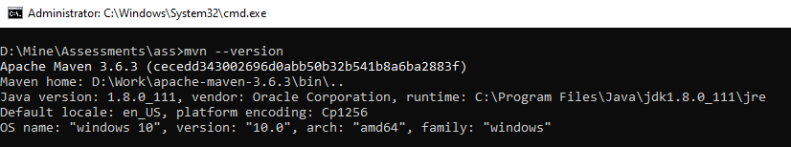

Got to the project root as:

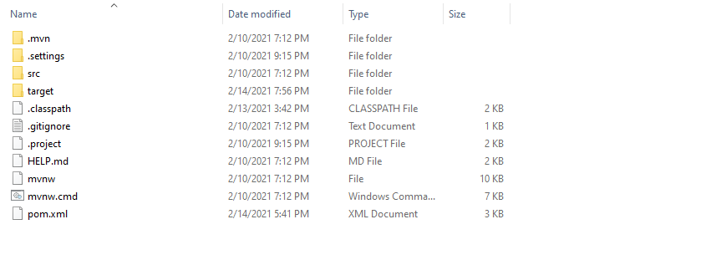

Open cmd and navigate to the project root like above.

Run below commands in order:

1. mvn clean install -DskipTests
2. mvn spring-boot:run

to tun test cases , run below commands:

1. mvn test